**INSIGHT STREAM: NAVIGATE THE NEWS**

**LANDSCAPE** (**React application**)

**GLOBAL NEWS**

**Team Leader:** Jayashree R

**Team Members:** Jeevitha V, Kavitha R, Kaviya V

**Introduction:**

Insight Stream: Navigate then News is an innovative platform designed to guide users through a rich journey of understanding and awareness. It starts with *Navigate*, offering an intuitive exploration of key trends, strategies, and insights across various sectors. Once you've charted your course, *News* takes you to the latest developments and updates, ensuring you remain at the forefront of what's happening in real-time.

**Description:**

* Welcome to the forefront of news discovery with Insight Stream! Our innovative web application is carefully designed to push the limits of traditional news consumption, catering to a wide array of interests from passionate news followers to expert information professionals. With a focus on an intuitive interface, real-time updates, and powerful features like personalized recommendations, Insight Stream is set to transform the way news is discovered and experienced. The platform also provides easy access to diverse multimedia content, allowing users to not only read but also watch and interact with the news as it unfolds.
* Built with a commitment to an elegant and user-friendly design, Insight Stream offers an immersive journalistic journey. Effortlessly navigate through an expansive range of news topics with tools like dynamic search, tailored filters, and trending stories, bringing the latest and most pertinent stories from around the globe directly to you. Additionally, the application’s seamless integration with social media allows users to stay connected and share news in real time.
* Embark on this enriching journey with us, where cutting-edge technology and traditional journalism converge. Each interaction with Insight Stream brings you closer to global events, exclusive interviews, expert commentary, and unique perspectives. Join us to experience the next evolution in news consumption, where every feature is thoughtfully designed to offer a glimpse of the future of staying informed.
* Enhance your news exploration with Insight Stream, where every story unlocks a world of knowledge waiting to be explored and understood. Rely on Insight Stream to be your trusted guide in staying connected to the heartbeat of the world, offering a comprehensive and dynamic approach to how we stay informed in today’s rapidly changing world.

**Scenario Based Introduction:**

After a hectic day at work, you're rushing home with your phone in hand, completely out of touch with what's going on in the world. Then, it hits you – you remember Insight Stream, the app you downloaded that promised to change the way you experience news. Curious, you open the app, and instantly, you're greeted with vibrant images, breaking headlines, and articles across various topics. This isn’t your usual news feed; it feels fresh, exciting, and easy to navigate. You decide to tap on a category and explore further, eager to see how Insight Stream is reshaping the way news is delivered and consumed. You're ready to discover a new way to stay informed.

**Technical Architecture:**

A news app's user-to-business data presentation starts with **content aggregation**, where news is sourced from publishers via APIs, RSS feeds, or web scraping. The system then processes and categorizes articles using **AI and NLP algorithms**, ensuring personalized recommendations. As users engage by reading, liking, or sharing content, their interactions generate valuable **behavioural data**. This data is analysed using **machine learning models** to enhance it.

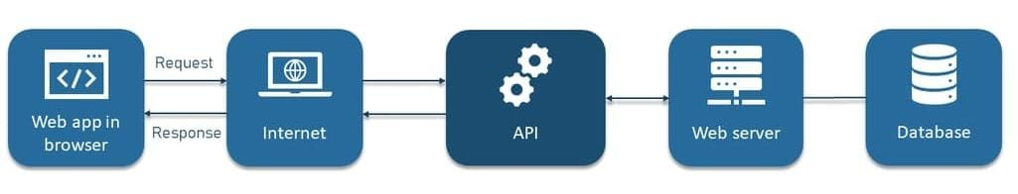**Project Goals and Objectives:**

The primary goal of Insight Stream is to create an intuitive and accessible platform designed for individuals who are passionate about staying informed, discovering a wide range of news topics, and receiving real-time updates.

The key objectives of the project are as follows:

* **Enhanced User Experience:** Build an interface that is straightforward and user-centric, ensuring that users can easily access, save, and share articles that align with their interests. The platform should be designed with usability in mind, offering seamless navigation and interaction.
* **Comprehensive News Organization:** Develop robust features for efficient content management, allowing users to organize news based on their preferences. The platform will include sophisticated search functionality to deliver a personalized and tailored news consumption experience.
* **Technology Stack:** Employ cutting-edge web development technologies, such as React.js, to ensure an efficient and enjoyable user interface

### **Key Features of Insight Stream:**

* **Extensive News Coverage from API Sources** – Gain access to a comprehensive collection of global news, spanning diverse categories and topics to ensure well-rounded and up-to-date information.
* **Engaging Visual News Experience** – Stay informed with a visually enriched news exploration, featuring curated image galleries that enhance the discovery of trending and breaking stories.
* **User-Centric Interface** – Enjoy a seamless browsing experience with an elegant, modern design that prioritizes clarity, ease of navigation, and an intuitive presentation of news.
* **Powerful Search Functionality** – Effortlessly find news on specific subjects with an advanced search tool that delivers personalized and relevant content based on user preferences.

**Pre-Requisites:**

Here are the key prerequisites for developing a frontend application using React.js:

* **Node.js and npm**: Node.js is a powerful JavaScript runtime environment that allows you to run JavaScript code on the local environment. It provides a scalable and efficient platform for building network applications. Install Node.js and npm on your development machine, as they are required to run JavaScript on the server-side.

● Download: <https://nodejs.org/en/download/>

● Installation instructions: <https://nodejs.org/en/download/package-manager/>

* **React.js**: React.js is a popular JavaScript library for building user interfaces. It enables developers to create interactive and reusable UI components, making it easier to build dynamic and responsive web applications.

**Install React.js, a JavaScript library for building user interfaces**.

● Create a new React app:

npx create-react-app my-react-app

Replace my-react-app with your preferred project name.

● Navigate to the project directory:

cd my-react-app

● Running the React App:

With the React app created, you can now start the development server and see your React application in action.

● Start the development server:

npm start. This command launches the development server, and you can access your React app at <http://localhost:3000> in your web browser.

* **HTML, CSS, and JavaScript:** Essential for structuring, styling, and adding interactivity to the application.
* **HTML:** Defines the fundamental structure and content of the app.
* **CSS:** Enhances visual presentation, layout, and responsiveness.
* **JavaScript:** Enables dynamic behavior and client-side interactivity.
* **Version Control with Git:** Facilitates collaboration, tracks changes, and ensures code integrity.
* **Repository Hosting:** Platforms like GitHub and Bitbucket provide secure and efficient code management.
* **Version Control:** Use Git for version control, enabling collaboration and tracking changes throughout the development process. Platforms like GitHub or Bitbucket can host your repository. • Git: Download and installation instructions can be found at: <https://git-scm.com/downloads>
* **Development Environment:** Choose a code editor or Integrated Development Environment (IDE) that suits your preferences, such as Visual Studio Code, Sublime Text, or WebStorm.

• Visual Studio Code: Download from <https://code.visualstudio.com/download>

To install and run the Application Project from google drive:

* **Get the code:** <https://drive.google.com/file/d/1-QEM0y-uPGzgoMN-cR8vyyMoqWmlHUQ8/view?usp=sharing>
* Download the code from the drive link given below
* **Install Dependencies:**

• Navigate into the cloned repository directory and install libraries:

cd news-app-react npm install

* **Access the App:**

• Open your web browser and navigate to <http://localhost:3000>.

• You should see the applications homepage, indicating that the installation and setup were successful.

* You should see the applications homepage, indicating that the installation and setup were successful. You have successfully installed and set up the application on your local machine. You can now proceed with further customization, development, and testing as needed.

**Project Structure for a News Application:**

In this project, we’ve split the files into 4 major folders, Components, Context, Pages and Styles. In the pages folder, we store the files that acts as pages at different URLs in the application. The components folder stores all the files, that returns the small components in the application. The context Api will be coded in the context folder. All the styling css files will be stored in the styles folder.

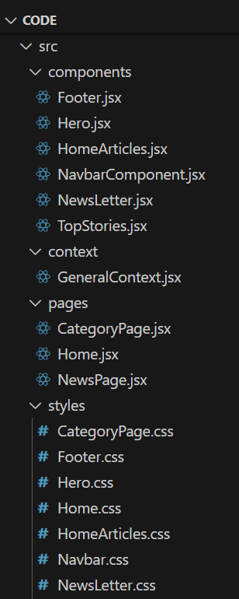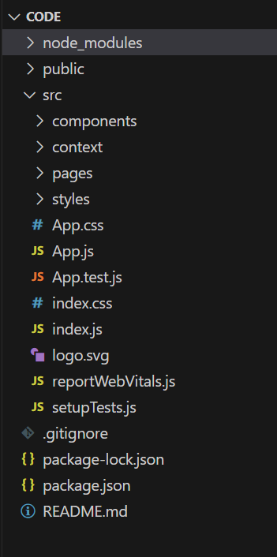

**Project Flow:**

**Project demo:**

Before starting to work on this project, let’s see the demo.

Demo link: <https://drive.google.com/file/d/1U3T2iSl06mxz4iRI7HOfNQDWtUZwEwB_/view?usp=sharing>

Use the code in:<https://drive.google.com/file/d/1-QEM0y-uPGzgoMN-cR8vyyMoqWmlHUQ8/view?usp=sharing>

**Milestone 1: Project setup and configuration**.

● Installation of required tools:

To build InsightStream, we'll need a developer's toolkit. We'll use React.js for the interactive interface, React Router Dom for seamless navigation, and Axios to fetch news data. For visual design, we'll choose either Bootstrap or Tailwind CSS for pre-built styles and icons.

Open the project folder to install necessary tools. In this project, we use:

* React Js
* React Router Dom
* React Icons
* Bootstrap/tailwind css

● For further reference, use the following resources

* <https://react.dev/learn/installation>
* <https://react-bootstrap-v4.netlify.app/getting-started/introduction/>
* <https://axios-http.com/docs/intro>
* <https://reactrouter.com/en/main/start/tutorial>

**Milestone 2: Project Development:**

❖ Setup the Routing paths Setup the clear routing paths to access various files in the application.

❖ Develop the Navbar and Hero components

❖ Code the popular categories components and fetch the categories from newsapi.

❖ Also, add the trending news in the home page.

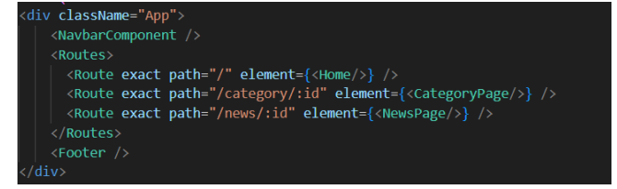

❖ Additionally, we can add the component to subscribe for the newsletter and the footer

❖ Now, develop the category page to display various news articles under the different categories.

**Important Code snips:**

**Fetching Top/Trending news**

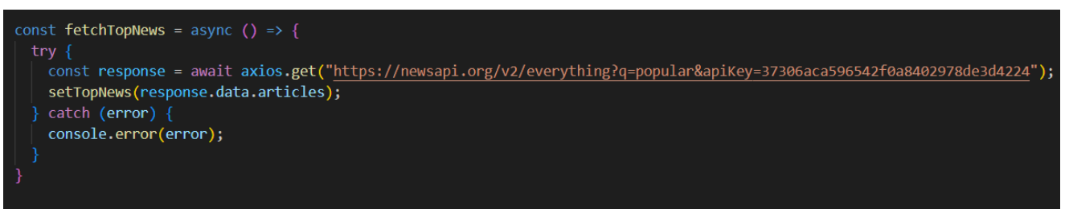With the API request, we fetch the trending news articles.

The code snippet shows a function written in Python called fetchTopNews that fetches news articles from an API. Here's a breakdown of the code:

**Async function fetchTopNews:**

The code defines an asynchronous function named fetchTopNews. An asynchronous function is used to handle asynchronous operations, such as making API requests that take time to complete.

**try...catch block:**

● The try...catch block is used to handle the API request.

● The try block contains the code that attempts to fetch data from the API using axios.get.

● axios is an external Python library for making HTTP requests. If you don't already use Axios in your project, you'll need to install it using a package manager like pip.

● The .get method makes a GET request to the specified URL.

**Fetching news by search/category**

With the specific category or search keyword, we use API request to fetch all the news articles related to that.

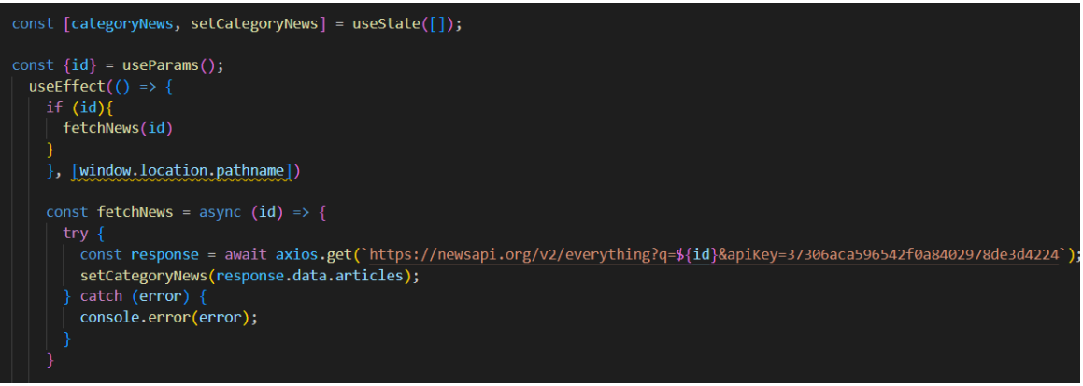

The code snippet shows a function called get_news_articles that fetches news articles from a news API. Here's a breakdown of the code:

**Imports:**

The code starts by importing the requests library. The requests library is a popular Python library for making HTTP requests. If you don't already have it installed in your project, you can install it using pip install requests.

**API Key**:

The line API_KEY = 'YOUR_API_KEY' defines a variable named API_KEY and assigns it a placeholder value 'YOUR_API_KEY'. You should replace this with a placeholder instructing users to replace it with their own API key obtained from the news API provider they want to use.

**Function Definition (get_news_articles):**

The code defines a function named get_news_articles that takes two parameters:

● query: This parameter is likely a string representing the search query for news articles.

● source: This parameter is likely a string representing the news source (e.g., 'bbc-news', 'cnn').

**Building the API Request URL:**

The line url = f'https://newsapi.org/v2/everything?q={query}&apiKey={API_KEY}' constructs the URL for the API request using a formatted string literal (f-string).

The URL includes the following parts:

● Base URL: <https://newsapi.org/v2/everything>

● Query parameters:

● q: This parameter is set to the query argument passed to the function.

● apiKey: This parameter is set to the API_KEY variable, which should contain the user's API key.

**Making the API Request (requests.get):**

The line response = requests.get(url) sends a GET request to the API URL constructed earlier. The requests.get function from the requests library is used to make the HTTP request. The response from the API is stored in the response variable.

**Error Handling (try...except block):**

● The try...except block is used to handle potential errors during the API request.

● The try block contains the code that attempts to fetch data from the API using requests.get(url).

● The except block handles any exceptions that might occur during the request, such as network errors or invalid API responses. In this case, it prints an error message to the console using print(f'Error fetching news articles: {e}').

**PROJECT EXECUTION:**

After completing the code, run the react application by using the command “npm start” or “npm run dev” if you are using vite.js. Here are some of the screenshots of the application.

**1.Hero components**

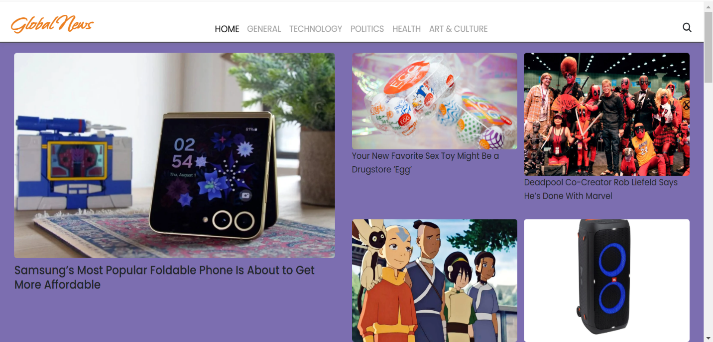In the hero component, the trending news articles are displayed. It is to highlight them. Apart from that, the search bar is also available to search for various articles and categories.

**2.Popular categories**

In the hero component, the trending news articles are displayed. It is to highlight them. Apart from that, the search bar is also available to search for various articles and categories.

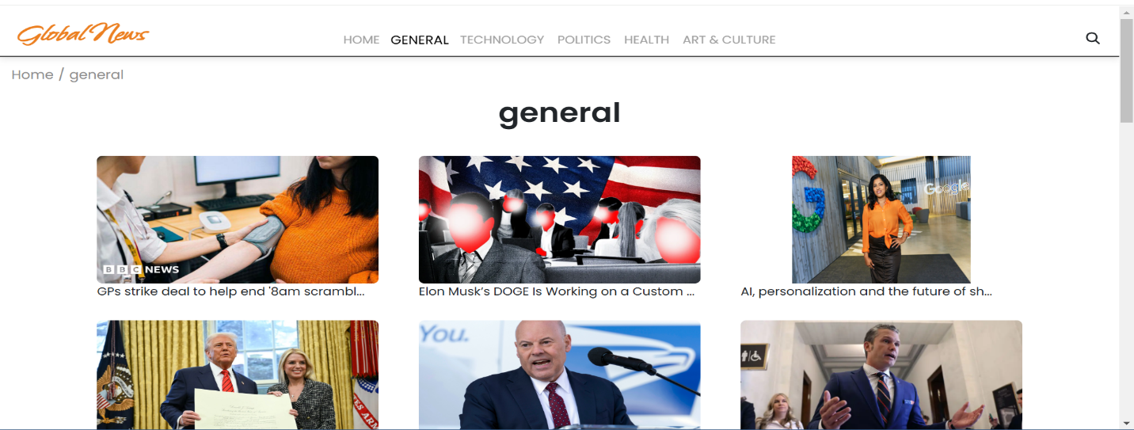

**3.Newsletter**

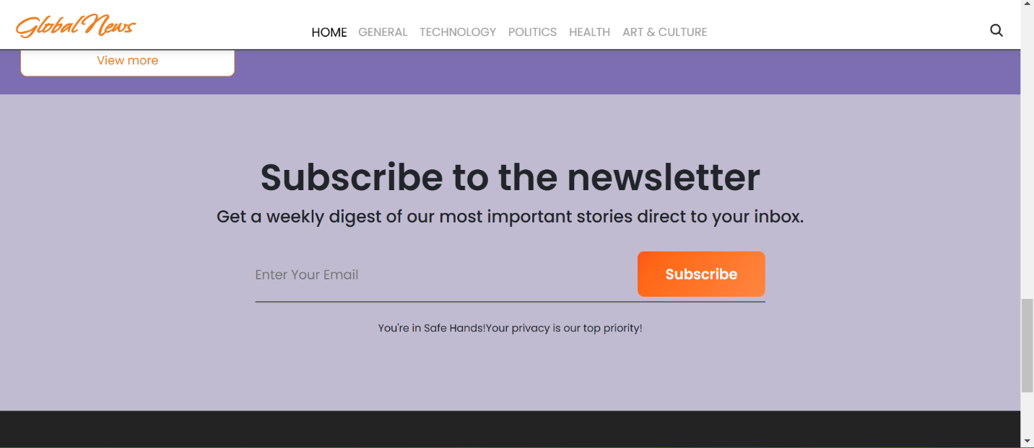Staying informed is key! This section would act as a magnet for users who want to stay up-to-date on the latest news. A brief signup form with an email field would be presented, along with a clear call to action button like "Subscribe Now" or "Get Daily News Updates." With a simple click, users can join the Insight Stream community and receive accurated news delivered straight to their inbox News Updates

**4.Category/Search result page**

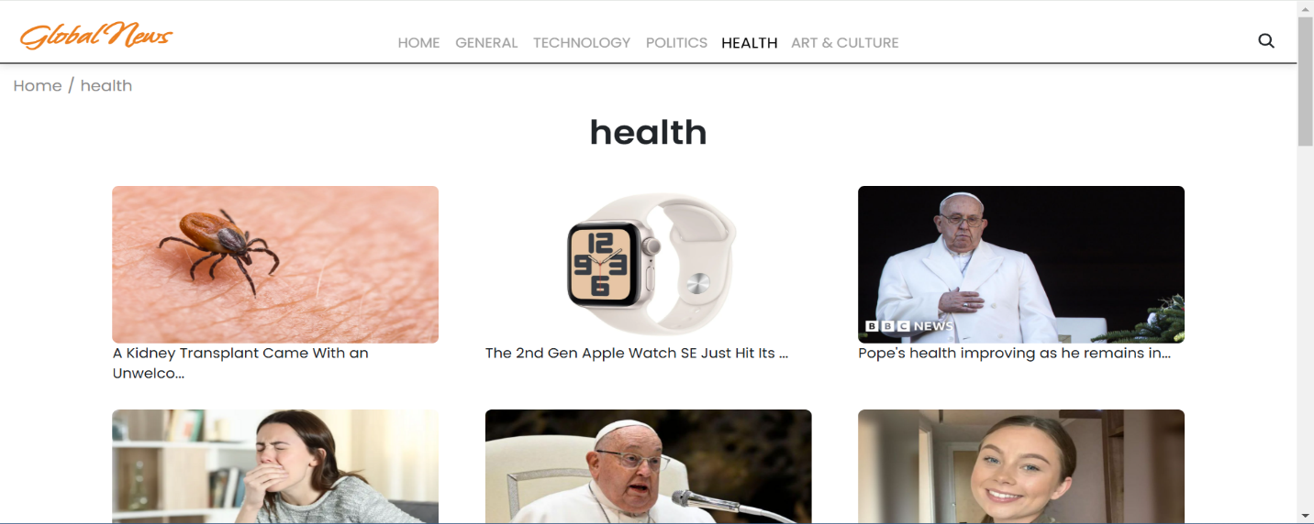Finding the news you crave is effortless with InsightStream. This page displays a neatly organized list of articles matching your chosen category or specific search query. Each entry would provide a clear headline, a concise summary, and if available, an image to give you a quick glimpse into the story. To further refine your exploration, filters or sorting options might be available. Imagine narrowing down results by date, source, keyword, or other relevant criteria to pinpoint exactly what you're looking for.

**5.Redirected Article Page:**

This is where you dive deep! The article page proudly displays the complete news story, retrieved directly from the original source. To keep you engaged and exploring related topics, the page might also suggest additional articles based on the current story. These suggestions can open doors to a world of interconnected information, allowing you to become a well-rounded news connoisseur**.**

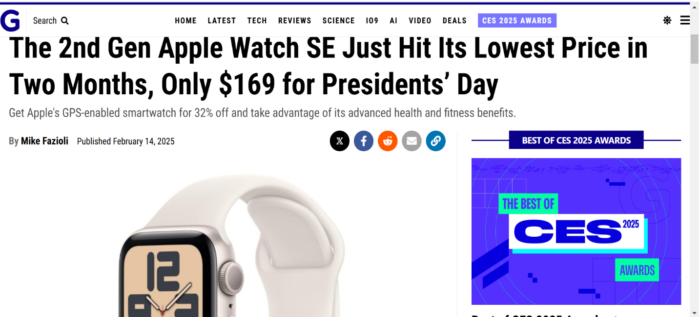

**Project Demo Video Link:**

<https://drive.google.com/file/d/1U3T2iSl06mxz4iRI7HOfNQDWtUZwEwB_/view?usp=sharing>

*** Thank you!!Happy coding!! ***